**Duplicate Image Detection**

**A PROJECT REPORT**

***Submitted By***

**Aarushi Sharda (140770107001)**

***In fulfillment for the award of the degree***

***of***

**BACHELOR OF ENGINEERING**

**in**

**Computer Engineering**



SILVER OAK COLLEGE OF ENGINEERING AND TECHNOLOGY, AHMEDABAD

**Gujarat Technological University, Ahmedabad**

December, 2017

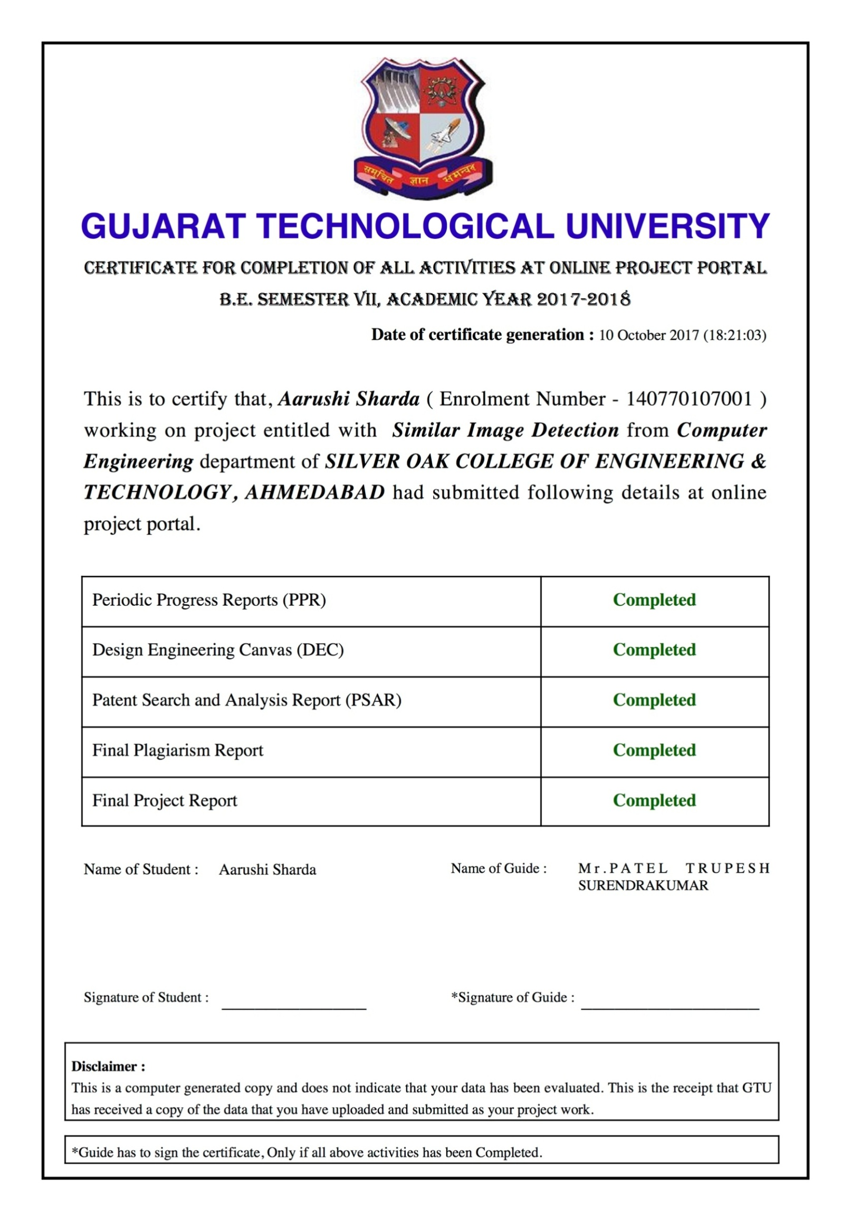

**Silver Oak College of Engineering & Technology**

Computer Engineering

2017

**CERTIFICATE**

**Date:**

**This is to certify that the Project Work entitled “SIMILAR IMAGE DETECTION” has been carried out by Aarushi Sharda (140770107001) under my guidance in partial fulfillment of the degree of Bachelor of Engineering in Computer Engineering (7th Semester) of Gujarat Technological University, Ahmedabad during the academic year 2017-18.**

Internal Guide Head of Computer Engineering Department

SOCET SOCET

**Candidate’s Declaration**

I hereby declare that project report titled “Duplicate image detection” submitted towards the completion of project in 7thsemester of bachelor of Computer Engineering in Silver Oak College Of Engineering & Technology, Ahmedabad is an authenticate record of my work carried out.

I further declare that to the best of our knowledge the report of C.E. 7thsemester.

Candidate’s signature **:**

Candidate’s name **: Aarushi Sharda**

Branch **: CE**

Enrollment Number **: 140770107001**



**ABSTRACT**

Today, most search engines and web portals are made interactive by the use of relatable images and graphics that make the user interaction easier and more interesting. Images form a large fraction of any website – be it the background image, the logos or even the tabs! We are surrounded by images and rely on them for effective navigation and use of websites and applications.

One of the most interesting and useful feature provided by multiple search engines and websites is the use of images in search results. With the help of facilities like images.google.com, we can snap and search any landscape, building, bird, food, etc.

Image databases are highly useful and can also be used in detecting fraudulent activities like using a company’s watermark illegally or even in uploading of credit card publicly.

A very common drawback for most such features is displaying of duplicated images. Take, for example, the search result for a specific chocolate. Most likely than not, it will consist of the same image multiple times over.

Hence, for ease of image recovery and search ability, it is necessary to find a solution for removal of duplicate images. The following project aims at recognizing duplicate or similar images. It has many more uses than just efficient searching – avoid adding duplicate images in a database, detect or find for similar products in a commercial site, etc

**ACKNOWLEDGEMENT**

I am highly indebted to my guide, Mr. Trupesh Patel, for his guidance and constant supervision as well as for providing necessary information regarding the project.

I would like to express my gratitude towards my parents and friends for their kind co-operation and encouragement which helped me in completion of this project.

My thanks and appreciations also go to my colleagues in developing the project and people who have willingly helped me out with their abilities.

**LIST OF FIGURES**

|  |  |  |
| --- | --- | --- |
| **2.1** | **Incremental model** | **8** |
| **2.2** | **Process Scheduling** | **10** |
| **4.1** | **Use case** | **26** |
| **4.2** | **ER Diagram** | **27** |
| **4.3** | **Activity diagram – login** | **28** |
| **4.4** | **Activity diagram – view history** | **29** |
| **4.5** | **Activity diagram – upload images** | **30** |
| **4.6** | **Activity diagram – sign up** | **31** |
| **4.7** | **Context flow diagram** | **35** |
| **5.1** | **Logical description of data** | **39** |
| **5.2** | **Flowchart** | **40** |
| **5.3** | **Mockup** | **42** |
| **5.4** | **State transition diagram** | **42** |

**LIST OF TABLES**

|  |  |  |
| --- | --- | --- |
| **2.1** | **Incremental model** | **10** |
| **2.2** | **Process Scheduling** | **11** |
| **4.1** | **User** | **32** |
| **4.2** | **Image** | **33** |
| **4.3** | **History** | **34** |

|  |  |
| --- | --- |
| **TABLE OF CONTENTS** | |
| **Title** | **Page no.** |
| Project Completion Certificate …………………………………….. | ii |
| Candidate’s declaration …………………………………………… | iv |
| Plagiarism Certificate …………………………………………….... | v |
| Abstract …………………………………………………………….. | vi |
| Acknowledgement …………………………………………………. | vii |
| List of Figures ……………………………………………………… | viii |
| List of Tables ………………………………………………………. | ix |
| **Chapter 1** |  |
| 1.1 Project Summary ………………………………………………. | 1 |
| 1.2 Purpose ………………………………………………………… | 1 |
| 1.3 Scope …………………………………………………………... | 1 |
| 1.4 Technology and Literature Review ……………………………. | 2 |
| **Chapter 2** |  |
| 2.1 Project planning and scheduling ……………………………….. | 6 |
| 2.1.1 Project Development Approach ……………………………… | 6 |
| 2.1.2 Project Plan ……………………………………….………….. | 9 |
| 2.1.3 Milestone and Deliverables ………………………………….. | 9 |
| 2.1.4 Role and Responsibilities ………………………...………….. | 10 |
| 2.2 Risk Management ………………………………………..…….. | 11 |
| 2.2.1 Risk Planning ……………………………………………..….. | 12 |
| 2.3 Cost Estimation …………………………………………….….. | 12 |
| **Chapter 3** |  |
| 3.1 User Characteristics ………………………………….……….. | 17 |
| 3.2 Hardware and Software Requirements ………………………… | 18 |
| 3.3 Costraints ………………………………………………………. | 19 |
| **Chapter 4** |  |
| 4.1 Study of Current System ……………………………………….. | 21 |
| 4.2 Problem and Weaknesses of Current System………………….. | 22 |
| 4.3 Requirements of New System …………………………………. | 23 |
| 4.4 Feasibility Study ……………………………………………….. | 24 |
| 4.5 Requirements Validation ………………………………………. | 25 |
| 4.6 Functions of System …………………………………………… | 26 |
| 4.6.1 Use Case ……………………………………………………... | 26 |
| 4.7 Data Modeling …………………………………………………. | 27 |
| 4.7.1 E-R diagram ………………………………………………….. | 27 |
| 4.7.2 System Activity or Object interaction Diagram ……………... | 28 |
| 4.7.3 Data Dictionary ………………………………………………. | 32 |
| 4.8 Functional and Behavioral Modeling ………………………….. | 35 |
| 4.8.1 Context Diagram ………………………………………….….. | 35 |
| 4.9 Main Modules Of New System ………………………………... | 36 |
| 4.10 Selection of Hardware and Software and Justification ……….. | 37 |
| **Chapter 5** |  |
| 5.1 Database Design/Data Structure Design ……………………….. | 39 |
| 5.1.1 Documents and Relationship ………………………………… | 39 |
| 5.2 System Procedural Design ……………………………………... | 39 |
| 5.2.1 Designing Pseudo code or algorithm for Method or operations | 39 |
| 5.2.2 Flow chart or activity design ………………………………… | 40 |
| 5.3 Input/output and Interface Design ……………………………... | 41 |
| 5.3.1 Samples Of Forms, Reports and Interface …………………… | 41 |
| 5.3.2 Access Control and Security …………………………………. | 42 |
| 5.3.3 State-Transition Diagram ……………………………………. | 43 |
| 5.4 System Architecture Design ………..………………………….. | 43 |
| GTU Portal Entities ………………………………………………... | 45 |

**CHAPTER: 1**

**INTRODUCTION**

**CHAPTER 1**

**INTRODUCTION**

**1.1** **Project Summary**

* In this project we will be developing things in two parts.
  + A library which provides with metadata related to images, which gets fed in as a learning database.
  + A server which operates on this data and gives the facility of checking duplicate images and also uploading images.
  + A basic client which can register, login and perform image upload and duplicate image identification operations using the web panel.

**1.2 Purpose**

* The tool can serve as a powerful medium for various individuals/organizations where they deal with large sets of images. For example, an E-commerce which uploads various products and wants to keep their catalogue free of duplicate entries. It can also be used to create a powerful recommendation system based on user browsing behavior

**1.3 Scope**

The scopes are mentioned below:

* **Generate metadata from an image:** The image goes through an algorithm which extracts all possible metadata from an image, this helps us describe an image in more descriptive and programmatically feasible way to operate on later.
* **Provides an interface for image operations:** This is done using a server, which can take input over HTTP protocol and feed it to binary for metadata generation and also has the algorithm for operating on metadata to find similar/duplicate images. Server is separated from client, as this gives capability of giving APIs to organizations who want to use their own client systems.
* **Provides image management to users:** User can register and perform upload/detection operations on an image. He will have his own panel where he can see his uploads and his older results. User can also create API keys so that he can use his own client system to communicate directly with the system.

**1.4 Technology and Literature Review**

* Backend server will use node.js. Frontend server will use node.js, HTML, CSS and vaScript. The metadata extraction/similarity detection library will be developed using Java.
* Tools used are VS code and Intellij - community edition.
* We will follow the iterative model for developing this project and the whole project will be developed using the SDLC.

**Node.js**

* Node.js is a JavaScript platform which runs on server side to handle requests.
* Node.js is highly capable of managing multiple requests per second and has a vast set of libraries available at disposal via npm (node package manager), which gives us a lot of possible and efficient implementation of common world problems like user authentication, API management, response disposition. Currently node package manager has over 350,000 community submitted libraries.
* We will be using express.js, a really simple framework for implementing our APIs and clients.

**HTML**

* HTML is the standard way of providing content to client browser, the browser can read the markup and provides a visual representation of data sent from server.

**JavaScript:**

* JavaScript is becoming a standard way of programming logic over the world wide web, it supports the development of both client (loaded via HTML markup) and server side (node.js).

**Java:**

* JAVA has been going as a robust and safe way of implementing programming logic thanks to its decades of development, it is a stable platform where stability and accuracy is concerned.
* JAVA is platform independent, which makes the library for detection available on virtually any platform with enough processing power and JAVA support.

**MongoDB:**

* MongoDB is a flexible way of storing JSON documents to server, the benefit with JSON documents is of its loose structure, which basically allows us to have complex data stored as it is on the data store. It does not enforce Schema which allows the flexibility of having varying data attributes for same category of records.

**EJS (Embedded JavaScript Templates):**

* EJS is a templating language similar to what we have in JSP. Moreover, it provides a robust and simple way of implementing complex HTML generation

**CHAPTER: 2**

**PROJECT MANAGEMENT**

**CHAPTER 2**

**PROJECT MANAGEMENT**

**2.1 Project planning and scheduling**

* Project planning and scheduling marks the initiation of a project, this considers defining of requirements, allocation of tasks and creation of schedules. To help with project planning and scheduling, various software development lifecycle practices have been devised and based on scope, requirements, deliverable intervals and availability of resources a standard practice is selected.
* Ideally such projects are better suited for prototype model, but based on the number of people in team and periodic deliverables and updates by university this will be developed using iterative model. This way we can clearly give complete and concise updates/reports and also if there is a substantial change required in previous planning phase we can step back and inform the project guide if needed.

**2.1.1 Project Development Approach**

The development strategy will be:

* + Planning and division of scope of project.
  + Analysis & Design of various scopes of the project
  + Risk analysis for possible risks and their mitigation strategies
  + Ordering of various scopes
  + High level designing
  + Low level designing
  + Implementation
  + Manual testing
  + Documentation

As mentioned in project planning and scheduling, we will be going for iterative model.

The Iterative Software Process Model

* The iterative model is a particular implementation of a software development life cycle (SDLC) that focuses on an initial, simplified implementation, which then progressively gains more complexity and a broader feature set until the final system is complete. When discussing the iterative method, the concept of incremental development will also often be used liberally and interchangeably, which describes the incremental alterations made during the design and implementation of each new iteration.
* Unlike the more traditional waterfall model, which focuses on a stringent step-by-step process of development stages, the iterative model is best thought of as a cyclical process. After an initial planning phase, a small handful of stages are repeated over and over, with each completion of the cycle incrementally improving and iterating on the software. Enhancements can quickly be recognized and implemented throughout each iteration, allowing the next iteration to be at least marginally better than the last.
  + Planning & Requirements: As with most any development project, the first step is go through an initial planning stage to map out the specification documents, establish software or hardware requirements, and generally prepare for the upcoming stages of the cycle.
  + Analysis & Design: Once planning is complete, an analysis is performed to nail down the appropriate business logic, database models, and the like that will be required at this stage in the project. The design stage also occurs here, establishing any technical requirements (languages, data layers, services, etc) that will be utilized in order to meet the needs of the analysis stage.
  + Implementation: With the planning and analysis out of the way, the actual implementation and coding process can now begin. All planning, specification, and design docs up to this point are coded and implemented into this initial iteration of the project.
  + Testing: Once this current build iteration has been coded and implemented, the next step is to go through a series of testing procedures to identify and locate any potential bugs or issues that have have cropped up.
  + Evaluation: Once all prior stages have been completed, it is time for a thorough evaluation of development up to this stage. This allows the entire team, as well as clients or other outside parties, to examine where the project is at, where it needs to be, what can or should change, and so on.
* Advantages
  + Rapid turnaround, while it may seem like each stage of the iterative process isn’t all that different from the stages of a more traditional model like the waterfall method — and thus the process will take a great deal of time — the beauty of the iterative process is that each stage can effectively be slimmed down into smaller and smaller time frames; whatever is necessary to suit the needs of the project or organization. While the initial run through of all stages may take some time, each subsequent iteration will be faster and faster, lending itself to that agile moniker so very well, and allowing the life cycle of each new iteration to be trimmed down to a matter of days or even hours in some cases.
  + Suited for agile needs, while a step-by-step process like the waterfall model may work well for large organizations with hundreds of team members, the iterative model really starts to shine when it’s in the hands of a smaller, more agile team. Particularly when combined with the power of modern version control systems, a full “iteration process” can effectively be performed by a number of individual team members, from planning and design through to implementation and testing, with little to no need for outside feedback or assistance.
  + Easy adaptability, hinging on the core strength of constant, frequent iterations coming out on a regular basis, another primary advantage of the iterative model is the ability to rapidly adapt to the ever-changing needs of both the project or the whims of the client. Even fundamental changes to the underlying code structure or implementations (such as a new database system or service implementation) can typically be made within a minimal time frame and at a reasonable cost, because any detrimental changes can be recognized and reverted within a short time frame back to a previous iteration.
* Disadvantages
  + Costly Late-Stage Issues, it is possible that an unforeseen issue in design or underlying system architecture will arise late into the project. Resolving this could have potentially devastating effects on the time frame and costs of the project as a whole, requiring a great deal of future iterations just to resolve one issue.
  + Increased Pressure on User Engagement,unlike the waterfall model, which emphasizes nearly all user/client engagement within the initial stages of the project during a brief crunch time period, the iterative model often requires user engagement throughout the entirety of the process. This is sometimes an unfortunate obligation, since each new iteration will likely require testing and feedback from users in order to properly evaluate any necessary changes.

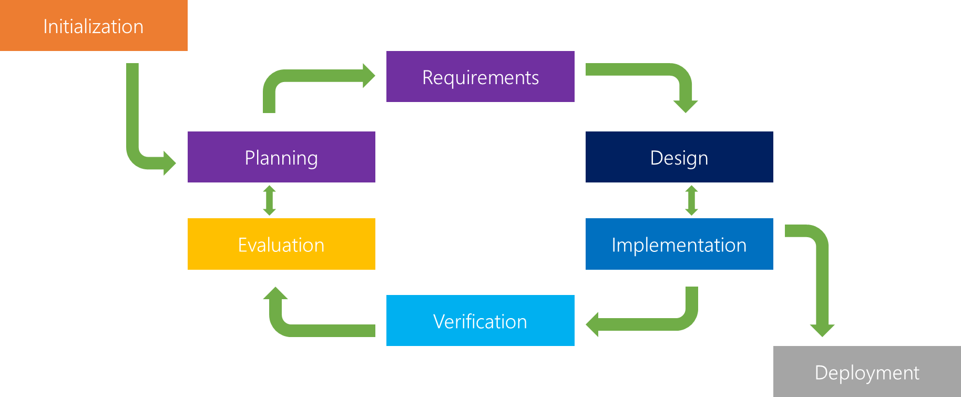

*Fig 2.1 Incremental model*

**2.1.2 Project Plan**

|  |  |  |
| --- | --- | --- |
|  | **From Date** | **To Date** |
| **1.Preliminary Investigation** | 3/7/2017 | 28/7/2017 |
| **2.Requirement Analysis** | 29/07/2017 | 19/8/2017 |
| **3.Designing** | 20/08/2017 | 21/09/2017 |
| **4.Implementation** | 11/10/2017 | 16/3/2018 |
| **5.Testing** | 17/3/2018 | 15/4/2018 |

**2.1.3 Milestone and Deliverables**

* First milestone will be framing of requirements after planning has been done. This will give a clear and concise definition of what we are going to achieve.
* Design for document will be delivered, designs covered will be a high level design which gives a bird’s eye view of the application architecture, and there will be a low level design which will give a brief of the data flow at near atomic levels
* After the designs have been delivered, implementation will commence. Implementation will be given in the following order,
  + JAVA library which will be responsible for generation of metadata
  + Server APIs using node.js and express.js
  + Client system using node.js, express.js & EJS
* Verification of the logic by the developer will be done, which will be proceeded by manual testing. Once that is done, the project will be given for verification to the project guide.
* After verification, list of queries will be analyzed and re-work will be done. (optional, if necessary)
* This will again go through verification and manual testing (optional, if list of queries occur in previous verification)
* After verification from the project guide is done, The project will be considered complete from developer’s end and will be submitted for evaluation.

**2.1.4 Role and Responsibilities**

Since this is a solely owned project development, following will be taken care of by Aarushi Sharda

* + Initialization
  + Planning
  + Requirements
  + Design
  + Implementation
  + Verification (developer level)

Final verification and evaluation will be done by the project guide and the university.

|  |  |  |  |  |  |  |  |  |  |  |  |  |  |  |  |
| --- | --- | --- | --- | --- | --- | --- | --- | --- | --- | --- | --- | --- | --- | --- | --- |
| Phase | From Date | To Date | J  U  N  E | J  U  L  Y | A  U  G | S  E  P | O  C  T | N  O  V | D  E  C | J  A  N | F  E  B | M  A  R | A  P  R | M  A  Y | |
| Initialization | 1/06/ 17 | 1/07/17 |  |  |  |  |  |  |  |  |  |  |  |  | |
| Planning | 1/07/17 | 1/08/17 |  |  |  |  |  |  |  |  |  |  |  |  | |
| Requirements | 1/08/17 | 1/09/17 |  |  |  |  |  |  |  |  |  |  |  |  | |
| Design | 1/09/17 | 1/11/17 |  |  |  |  |  |  |  |  |  |  |  |  | |
| Implementation | 1/11/17  1/04/ 17  *(2nd phase if needed)* | 1/03/18  1/05/ 17  *(2nd phase if needed)* |  |  |  |  |  |  |  |  |  |  |  |  | |
| Verification | 1/03/18 | 1/05/18 |  |  |  |  |  |  |  |  |  |  |  |  | |
| Evaluation | 1/05/18 | 30/05/18 |  |  |  |  |  |  |  |  |  |  |  |  | |
|  | | | | | | | | | | | | | | |  | |

*Figure 2.2: Project Scheduling*

**2.2 Risk Management**

Risk is an expectation of loss, a potential problem that may or may not occur in the future. It is generally caused due to lack of information, control or time.A possibility of suffering from loss in software development process is called a software risk. Loss can be anything, increase in production cost, development of poor quality software, not being able to complete the project on time. Software risk exists because the future is uncertain and there are many known and unknown things that cannot be incorporated in the project plan.

A software risk can be of two types

(a) internal risks that are within the control of the project manager

(b) external risks that are beyond the control of project manager.

Risk management is carried out to:

* Identify the risk
* Reduce the impact of risk
* Reduce the probability or likelihood of risk
* Risk monitoring

Risk identification and analysis

* Technical complexity involved for this project is pretty high due to the level of algorithms involved. The operations can get highly mathematical and complexity of operations can rise exponentially.
  + **Level: High**
* Complexity of the technology may end up selecting different language if situation demands.
  + **Level: High**
* Processing power required may be high due to mathematical nature of operations being performed on binary images
  + **Level: Medium**
* Availability of academic help when needed
  + **Level: Medium**
* Overshot deadlines
  + **Level: High**

**2.2.1 Risk Planning for the project**

* **Risk -** Technical complexity involved for this project is pretty high due to the level of algorithms involved, The operations can get highly mathematical and complexity of operations can rise exponentially.
* ***Resolution:*** *Periodically do retrospective and sync up with project guide for any academic help that might be needed.*
* **Risk -** Complexity of the technology may end up selecting different language if situation demands.
* ***Resolution -*** *Periodically note down capabilities/incapabilities of implementing a certain algorithm in JAVA, and decide early whether the technology will be feasible*
* **Risk -** Processing power required may be high due to mathematical nature of operations being performed on binary images
* ***Resolution -*** *Ensure the machine used for development/practical demonstration is capable enough and within the range of hardware requirements for the project.*
* **Risk -** Availability of academic help when needed
* ***Resolution -*** *Keep a check on when help might be needed and inform the respective person beforehand.*
* **Risk -** Overshot deadlines
* ***Resolution-*** *Sync up with project guide on regular basis and inform him/her of the progress and widen/shorten the scope as needed.*

**2.3 Cost Estimation**

Like all estimation models for software, the COCOMO models require sizing information.

Three different sizing options are available as part of the model hierarchy: object points, function points, and lines of source code.

Like function points, the object point is indirect software that is computed using counts of the number of

* + Screens (at the user interface),
  + Reports,
  + Components likely to be required to build the application.
* Once complexity is determined, the number of screens, reports, and components are weighted according to Table above.
* The object point count is then determined by multiplying the original number of object instances by the weighting factor in table above and summing to obtain a total object point count.
* When component based development or general software reuse is to be applied, the percent of reuse (%reuse) is estimated and the object point count is adjusted:
* **NOP = (object points) X [(100 - %reuse) /100].**
* Where NOP is defined as new object points. To derive an estimate of effort based on the computed NOP value, a “productivity rate” must be derived.
* **PROD=NOP /person-month**
* For different levels of developer experience and development environment maturity. Once the productivity rate has been determined, an estimate of project effort can be derived as Estimated effort =NOP/PROD.
* There are three types of software project:
  + Organic project
  + Semi-detached project
  + Embedded project
* **Cost required to develop project=effort*rs/month**
  + **Effort Estimation(E):**

In Organic=2.4 (KLOC)1.05PM

In semidetached=3.0(KLOC)1.12PM In Embedded=3.6(KLOC)1.20PM

* + **Duration Estimation(D):**

In Organic=2.5(effort)0.38months

In semidetached=2.5(effort)0.35months

In Embedded=2.5((effort)0.32months

* + **Person Estimation:**

P=E/D

KLOC=Kilo Line of Code

|  |  |  |
| --- | --- | --- |
| **Modules** | **Page** | **Estimated line of code** |
| JAVA Module | - | 4250 |
|  | Image contouring | 1500 |
|  | Histogram creation | 1250 |
|  | Tree generation | 500 |
|  | Image processing | 1000 |

|  |  |  |
| --- | --- | --- |
| **Modules** | **Page** | **Estimated line of code** |
| Node.js Server (Backend) | - | 3500 |
|  | Algorithm for matching | 2000 |
|  | API for image parsing and storing | 500 |
|  | Storing of metadata | 250 |
|  | Storing of actions of user | 500 |
|  | Session management and tokens | 250 |

|  |  |  |
| --- | --- | --- |
| **Modules** | **Page** | **Estimated line of code** |
| Node.js Server (Frontend) + HTML | - | 3500 |
|  | User dashboard | 1000 |
|  | API for communicating with backend | 500 |
|  | Storing of user profile | 500 |
|  | Registration | 500 |
|  | Show history/logs | 1000 |

* + - Total line of code=4250 + 3500 + 3500 = 11250
    - KLOC=11.25
  + We are using Organic Project Type,
    - **Effort Estimation (E):**

=2.4 (KLOC)1.05PM

=30.47 PM

* + - **Duration Estimation (D):**

= 2.5(effort)0.38 month

=2.5(30.47)0.38 months

=9.15 months

* + - **Project Cost:**

=effort*RS/month

=30.47*25000

=761,750

* Advantages of COCOMO:
  + COCOMO is factual and easy to interpret.
  + One can clearly understand how it works.
  + Accounts for various factors that affect cost of the project.
  + Works on historical data and hence is more predictable and accurate.
* Disadvantages:
  + COCOMO model ignores requirements and all documentation.
  + It ignores customer skills, cooperation, knowledge and other parameters.
  + It oversimplifies the impact of safety/security aspects.
  + It ignores hardware issues
  + It ignores personnel turnover levels
  + It is dependent on the amount of time spent in each phase.

**CHAPTER: 3**

**SYSTEM REQUIREMENTS STUDY**

**3.1 User Characteristics**

The users can be divided based on their usage requirements and the importance of the system in their day to day personal/business activities. The users for our system can be broadly classified to :

1. **Image enthusiasts/businesses**

* These are the people who deal with images on a day to day basis like photographers, digital studios.

1. **Day to day user**

* The are general public users who want to keep their image stores clean by removing redundant images.

1. **Businesses**

* This system can help the businesses who deal in data related to images. For example, E-commerce players who would like to utilize the data for their business needs.
* The system can also help businesses with primary feature as image uploading. For example. marketplaces like OLX where duplicate image entries can harm the quality of service that they provide.
* These businesses usually have workforce at their disposal to integrate the system with their business systems, this is where our API driven backend can actually benefit on a larger scale.

**3.2 Hardware and Software Requirements**

* The system is comprised of two parts
* Server side
* Client side
* Server side consists of:
* Backend API which deals with data related tasks. The requirements for this API are high CPU and RAM.
  + - Hardware requirements :
      * Xeon Processor
      * 64 GB RAM (assuming 50 MB RAM per user per operation, and servicing 1000 users)
      * For demo purposes, any entry level server (any device capable of running a server) can be used.
      * The requirements scale up based on the concurrent number of users in the system.
* Ideally a Xeon processor and 64 GB RAM can accommodate a reasonable traffic, however for demo purposes an entry level server can be used. The requirements scale with the increase in number of concurrent users using the system.
* Frontend Server which serves the website.
  + Hardware requirements
    - 1 Giga hertz CPU
    - 512 MB RAM
* The requirements for the frontend server are minimal and can work on any CPU above 1 Ghz and 512 MB RAM.
* Client Side:
  + Any client running Firefox 20+ Chrome 4+ Opera 15+ Safari 3.2+

**3.3 Constraints**

* There are no regulatory policies involved in running of the system, all the technologies used are open source or free to use for commercial/educational purposes
* Hardware limitations can exist only for the backend API as they are more CPU intensive and hence need to scale up with more number of operations
* Parallel operations for image metadata extraction will be there.
* Ideally we will have 8 workers (process) which will be at disposal to execute the operations.
* Higher order languages used in the system are JAVA and Node.js and they can run in minimal configuration.
* However the operations performed by them can require more system resources.
* The system will be
  + Reliable in terms of the operations performed, when a data is stored it will be readily available all the time.
  + The operations performed in case if they fail, a log will be maintained and the user will be notified of the state of operation.
  + User will be authenticated on the server side, and sensitive data like password will be stored as one way hashes to avoid anyone from deciphering the information.
* Considerations:
  + The user is assumed to be proficient in day to day web activities.
  + The user who uses API are familiar with concepts of token based authentication and have an expertise in communicating to secure REST APIs
  + The browser is totally capable of running Javascript
  + Image similarity data can never be accurate given the kind of data that can be generated from images.
  + There will always be some inconsistency and the user is aware of this.
  + The similarity score will be an indicative of how similar the data is.
  + The algorithm that we use can always be optimized endlessly for different sets of images.
  + For example, one type of algorithm may be good for nature images, while other can be good for facial detections.
  + Our solution is a general purpose solution and is a proof of concept of the service that can be offered to general users.

**CHAPTER: 4**

**SYSTEM ANALYSIS**

**4.1 Study of Current System**

The current system of image detection is in fact a very complicated one. The user needs to download a bunch of libraries, make them talk to each other by creating scripts or code and perform operations on the images and store the data on his system.

The user has to keep a check on which versions of libraries are compatible by what, and how to store the data. This gives the user a fine grained but complicated control over how he identifies similarity between the images.

There are also multiple softwares available which can do this operation but they run on the local machines of the user.

The benefits and disadvantages (mentioned in the coming sections) give us an opportunity to come up with the a web based service, which allows the user to not worry about the complexities involved and to have his image related requirements resolved with an ease.

**4.2 Problem and Weaknesses of Current System**

* The current system is a combination of various tools/libraries which can be made to talk to each other using scripts/code.
* The complexity involved in setting up the current system can be very typical and hence a lot of users refrain from setting these up.
* The current algorithms are vast and when a user is presented with the options to choose between them, he can be overwhelmed by the information that he needs in order to pick the right option.
* Since image operations can be CPU intensive, it often requires users to have good systems which are capable of running these tools.
* The user is expected to be technical in order to set up the current system.

**4.3 Requirements of New System**

* Non-Functional requirements
  + User should be able to register/login to the system
  + User should be able to upload images
  + User should be able to see the similarity score at any time
  + User should be able to see his history of operations performed
  + User should be able to perform similarity search operations asynchronously
  + User should be able to logout without any loss of data
  + User should be able to generate API keys to interact with the system via APIs
  + User should be able to change password
  + User should be able to reset password if he forgets it
  + The user should be able to perform all operations solely via web or REST APIs
  + The user should be able to access the features on any device capable of web activities and has a browser
* Functional requirements
  + The system must hash the password of the users
  + The system must store the images for later retrieval
  + The system must serve the image only to it’s owner
  + The system must generate metadata as soon as the image is uploaded. In case of failure the system should notify the user in the UI when the user opens his dashboard
  + The system should generate unique API keys in 256 bit format
  + The system must store the data in a nosql database.
  + The system must be capable of handling errors and should log any such occurrences in system logs.
  + The system must not resort to specific algorithm for a specific scenario. It should use contouring + histogram generation for metadata
  + The system must have enough hardware resources to cater the user activities
  + The system will serve users who are capable of performing authentication via API keys and will user rest or users who have javascript capable browsers.
  + Hardware requirements must be met as mentioned in requirements section.

**4.4 Feasibility Study**

The new system eases out a lot of user issues related to image metadata operations, in this case similarity detection. The new system is a software as a service and is capable of handling large scale of users using horizontal scaling and can be hosted on cloud. The requirements of current scenario are to be able to perform all the above mentioned operations reliably and securely and our system helps them achieve this.

The requirements of the system can be implemented by current technology with the current solutions available but the effort required to make various tools involved to talk to each other can be a challenging task. The cost and schedule constraints can range from same as current system to exponentially higher depending on the complexity of the tools involved.

The system can be integrated with already in place systems if and only if they are capable of communicating over internet services via REST APIs. In case if they are not, a web wrapper will be required from the user’s side in order for them to put our system in place.

**4.5 Requirements Validation**

* The image similarity index have been kept in range of what the user wants .
* The requirements related to user data have been identified, and will be implemented in the given constraints of security and validation.
* All functional and non functional requirements have been covered and have been verified.
* Requirements mentioned are in absolute forms and have clear definition of what the user wants, the only exception being the variation in similarity indexes.
* The limitation of the software has been clearly mentioned and the user understands this.

**4.6 Functions of System**

**4.6.1 Use Case**

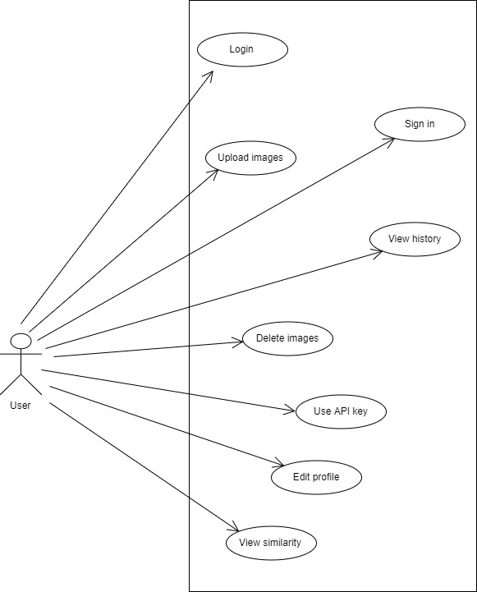

*Fig 4.1 Use Case*

**4.7 Data Modeling**

**4.7.1 E-R diagram**

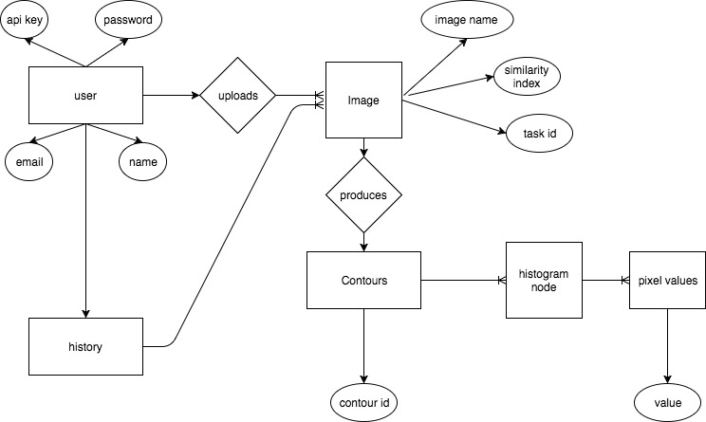

*Fig 4.2 ER diagram*

**4.7.2 System Activity or Object interaction Diagram**

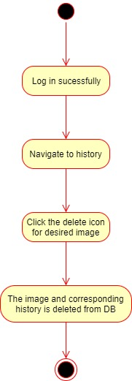

*Fig 4.3 Login*

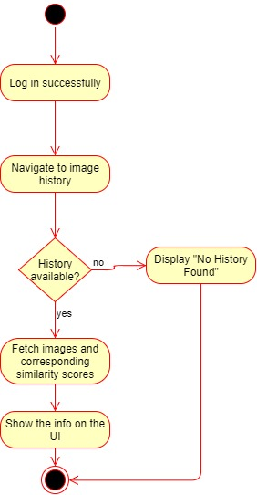

*Fig 4.4View history*

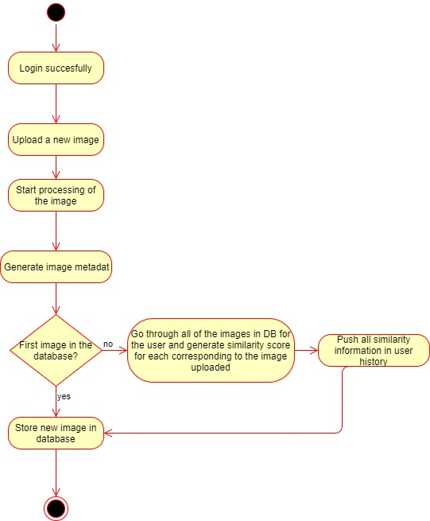

*Fig 4.5 Image upload*

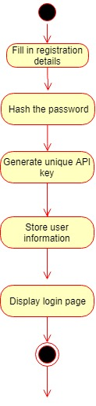

*Fig 4.6 Sign up*

**4.7.3 Data Dictionary**

|  |  |  |  |  |  |  |
| --- | --- | --- | --- | --- | --- | --- |
| **Project Name:** Duplicate Image detection | | | **Table Name:** User | | | |
| **Primary key:** user_id | | | **Foreign key:** none | | | |
| **Table Description:** This table stores all the information about registered users. | | | | | | |
| **Table structure** | | | | | | |
| **Field Name** | **Data Type** | **Size** | | **Constrains** | **Description** |
| user_id | ObjectID | 20 | | Primary key | This field contains user identity. |
| user_access_token | String | 40 | | Not null | This field contains an access token. |
| password_hash | String | 30 | | Not null | This field contains a hashed password. |
| username | String | 20 | | Not null | This field contains the username. |
| firstname | String | 30 | | Not null | This field contains the user’s firstname. |
| lastname | String | 30 | | Not null | This field contains the user’s lastname. |
| email | String | 60 | | Not null | This field contains the user’s email, |

*Table 4.1 User*

|  |  |  |  |  |  |  |
| --- | --- | --- | --- | --- | --- | --- |
| **Project Name:** Duplicate Image detection | | | **Table Name:** Image | | | |
| **Primary key:** image_id | | | **Foreign key:** none | | | |
| **Table Description:** This table stores all the information about stored images. | | | | | | |
| **Table structure** | | | | | | |
| **Field Name** | **Data Type** | **Size** | | **Constrains** | **Description** |
| image_id | ObjectID | 20 | | Primary key | This field contains image identity. |
| image_name | String | 40 | | Not null | This field contains the image name. |
| contours | Array | - | | Not null | This field has an array of contours. |
| contour_section | Object | - | | Not null | This field contains contour sections. |
| histogram | Object | - | | Not null | This field contains the rgb histograms. |
| values | Array | - | | Not null | This field contains an array of rgb values. |
| value | Number | - | | Not null | This field contains the independent r,g and b values |

*Table 4.2 Image*

|  |  |  |  |  |  |  |
| --- | --- | --- | --- | --- | --- | --- |
| **Project Name:** Duplicate Image detection | | | **Table Name:** History | | | |
| **Primary key:** history_id | | | **Foreign key:** user_id, image_id | | | |
| **Table Description:** This table stores all the history of the user. | | | | | | |
| **Table structure** | | | | | | |
| **Field Name** | **Data Type** | **Size** | | **Constrains** | **Description** |
| history_id | ObjectID | 20 | | Primary key | This field contains history identity. |
| user_id | ObjectID | 40 | | Foreign key | This field contains user identity. |
| image_id | ObjectID | 30 | | Foreign key | This field contains image identity. |
| similarities | Array | 20 | | Not null | This field contains the array of similarities. |
| similarity | Object | 30 | | Not null | This field contains the individual image’s similarity. |
| similarity_score | Number | 30 | | Not null | This field contains the generated similarity score. |
| history_id | ObjectID | 20 | | Primary key | This field contains history identity. |

*Table 4.3 History*

**4.8 Functional and Behavioral Modeling**

**4.8.1 Context Diagram**

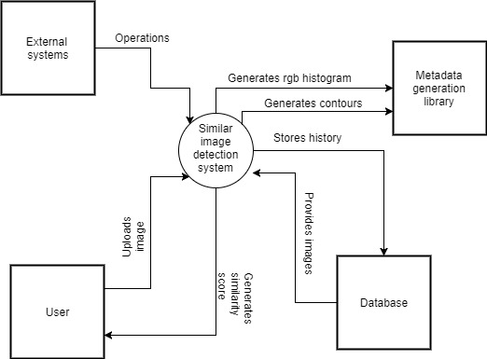

*Fig 4.7 Context flow diagram*

**4.9 Main Modules Of New System**

Modules represent the essential and significant components of a project. In the Duplicate image detection, the main modules are:

* User
* Image
* Contour
* Histogram

**User**

User is the most important module since the project would be useless if there is no user to use it.

A user in the Duplicate Image detection webpage can do a multitude of tasks including:

1. Upload images
2. View history
3. Delete images
4. Use API key
5. Edit profile
6. View similarity

There are a plethora of ways that our functionality can be used by a user. The main aim is to scan an image database and provide a similarity score for each image compared with the new image.

This is useful to E-commerce sites that want to restrict duplicate products, Digital studios that tend to have an extremely large database, Advertising companies that rely on visual recommendations, etc.

**Image**

An image is a two dimensional visual representation that has an innumerable amount of information. A single image can be used to generate a plethora of graphs and statistics.

Image processing has hence become one of the most wide-spread study and progress area. Our project is completely based on image processing and hence one of our most important module is image!

Each user has his own image database wherein he can store all relevant images and whenever a new image enters that database, it goes through each and every image already present and a similarity score is generated using our algorithm.

This similarity score is used to test whether or not a given image has a similar or duplicate image already present in the database.

**Contour**

Contour tracing is one of many preprocessing techniques performed on digital images in order to extract information about their general shape. Once the contour of a given pattern is extracted, its different characteristics will be examined and used as features which will later on be used in pattern classification. Therefore, correct extraction of the contour will produce more accurate features which will increase the chances of correctly classifying a given pattern.

For our project, whenever an image enters the database, a contour as well as a histogram are generated in the form of metadata. Each contour section in turn has an rgb histogram associated with it and is used to compare images.

**Histogram**

An rgb histogram is a representation of the distribution of colors in an image. For digital images, a color histogram represents the number of pixels that have colors in each of a fixed list of color range, that spans the image's color space, the set of all possible colors.

The color histogram can be built for any kind of color space, although the term is more often used for three-dimensional spaces like RGB or HSV. For monochromatic images, the term intensity histogram may be used instead. For multi-spectral images, where each pixel is represented by an arbitrary number of measurements (for example, beyond the three measurements in RGB), the color histogram is N-dimensional, with N being the number of measurements taken. Each measurement has its own wavelength range of the light spectrum, some of which may be outside the visible spectrum.

**4.10 Selection of Hardware and Software and Justification**

* For development purposes we are using the following
  + Ubuntu : This linux based OS has an amazing support for all the development tool required and has ability to provide with fine grained configuration of libraries easily.
  + VSCode: This editor is widely used by javascript community for frontend/node.js related task and has a good support for the language.
  + Intellij Community Edition: This IDE is renowned for it’s ease of use with JAVA based projects and has a better library integration support in case if we want to add any third party libraries to the project.
  + Development machine:
    - Laptop : for portability, plus the configuration is enough to run the above software and to run the servers required
      * Configuration
        + Core i5 + 4 GB RAM
* For demo purposes we will be using the same development machine as it is capable of showing demonstrations on a small scale

**CHAPTER: 5**

**SYSTEM DESIGN**

**5.1 Database Design/Data Structure Design**

**5.1.1 Documents and Relationship**

We have three documents (documents as we are using nosql, in this case mongodb)

User

Image

History

The relationships among these documents are as below

User ***- one to many -***  Image

User ***- one to many -***  History

**5.1.3 Logical Description Of Data**

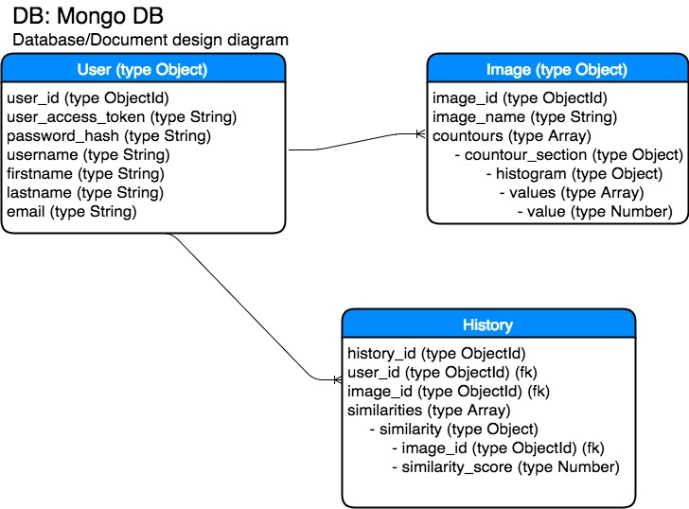

*Fig 5.1 Logical description of data*

**5.2 System Procedural Design**

**5.2.1 Designing Pseudo code or algorithm for Method or operations**

Algorithm for image detection

* User clicks upload button
* image_upload blob is stored in database
* image_upload is checked for contours
* Generate contours_generated
* For each contour in contours_generated
  + Generate histogram_generated and corresponding rgb_values_generated
* Persist contours_generated in image document
* For each image in images by user
  + Check if number of contours in image and contours_generated are within acceptable range of difference (difference in no. of contours), if yes then
    - For each contour in contours_generated
      * For each value in histogram_values
        + Compare value and rgb_values_generated
  + Generate a combined similarity score
  + Persist image, user and score in History document

**5.2.2 Flow chart or activity design**

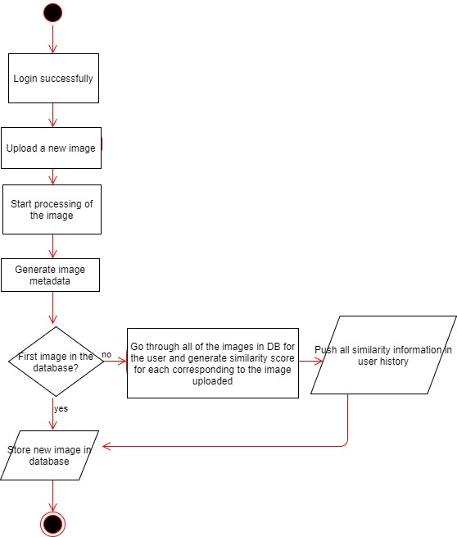

*Fig 5.2 Flowchart*

**5.3 Input/output and Interface Design**

**5.3.1 Samples Of Forms, Reports and Interface**

The code for UI is still a work in progress, the mockups for how it will look like is as below

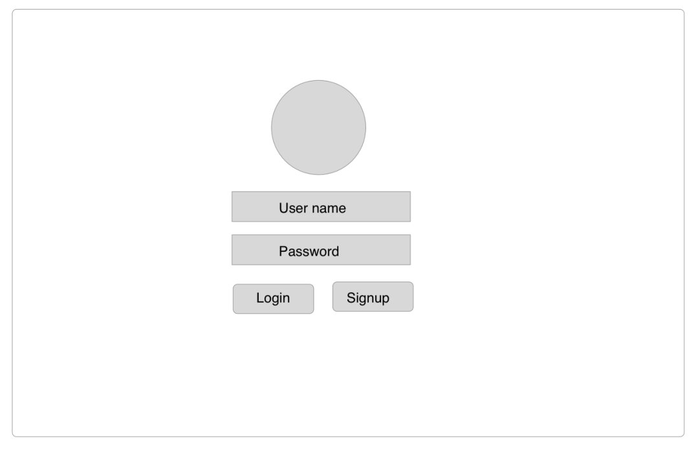

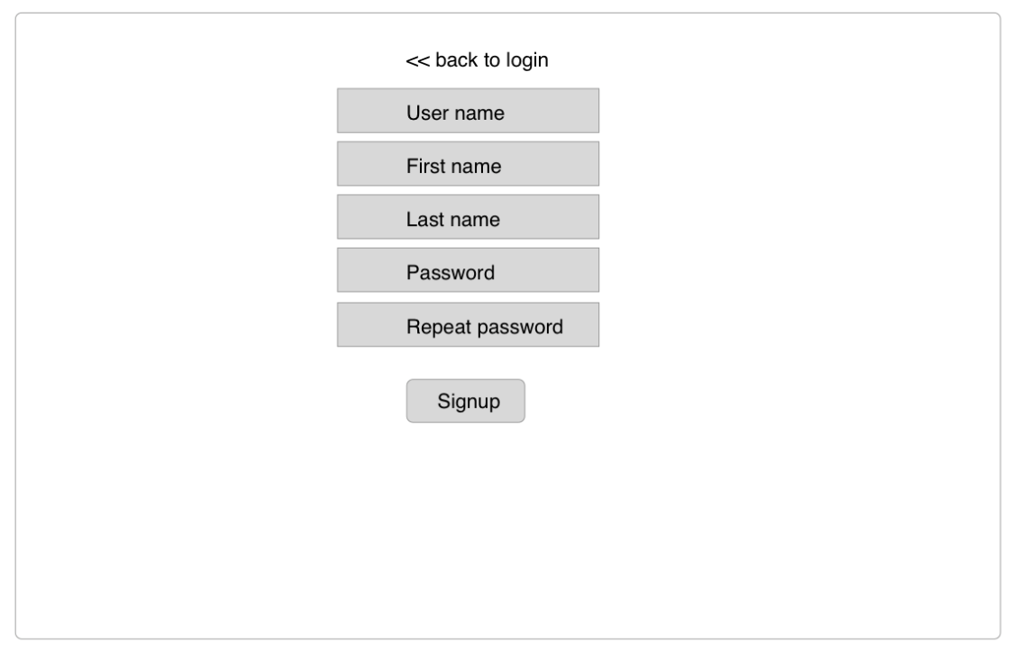

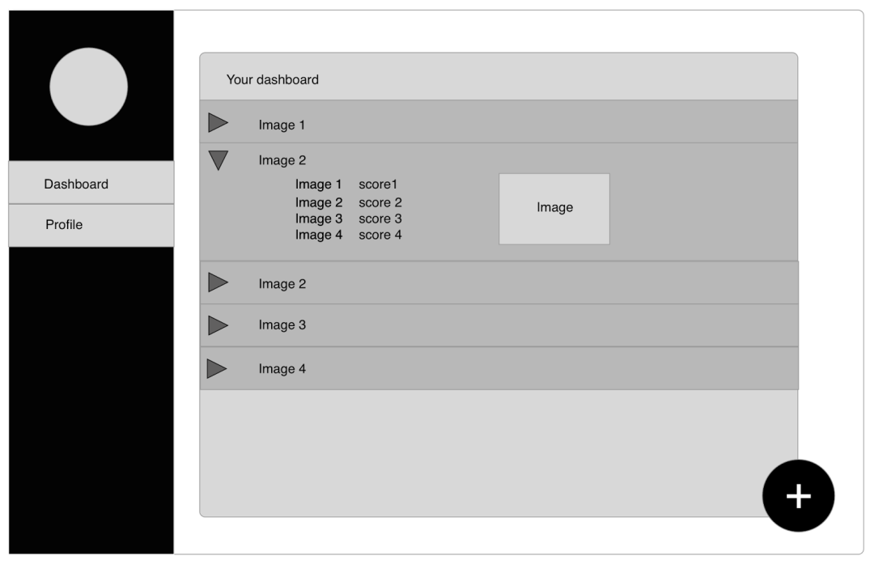

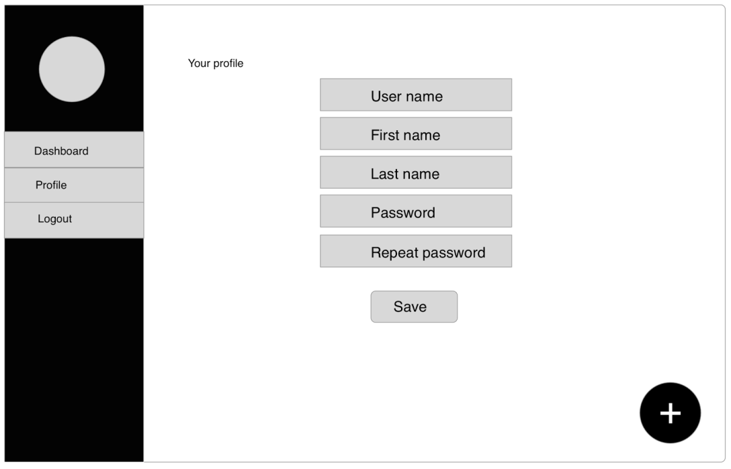

*Fig 5.3 Mockup*

**5.3.2 Access Control and Security**

* In the project a user data can be accessed only via 2 mechanisms
  + a ) Using login and system dashboard
  + b) Using external systems, using API key. Each API key will be unique and will be provided to every user.
* There is no admin management system, hence the system administrator/super user in server can access all of data
* User password will always be hashed (one way hash), hence in an event of data compromise from the server, a password can never be hacked.

**5.3.3 State-Transition Diagram**

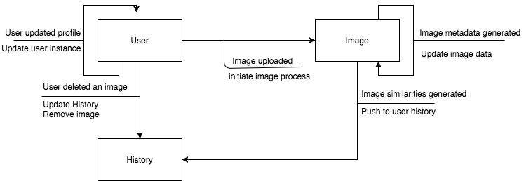

*Fig 5.4 State transition*

**GTU PORTAL ENTITIES**

1. **PPR (Periodic Progress Report)**

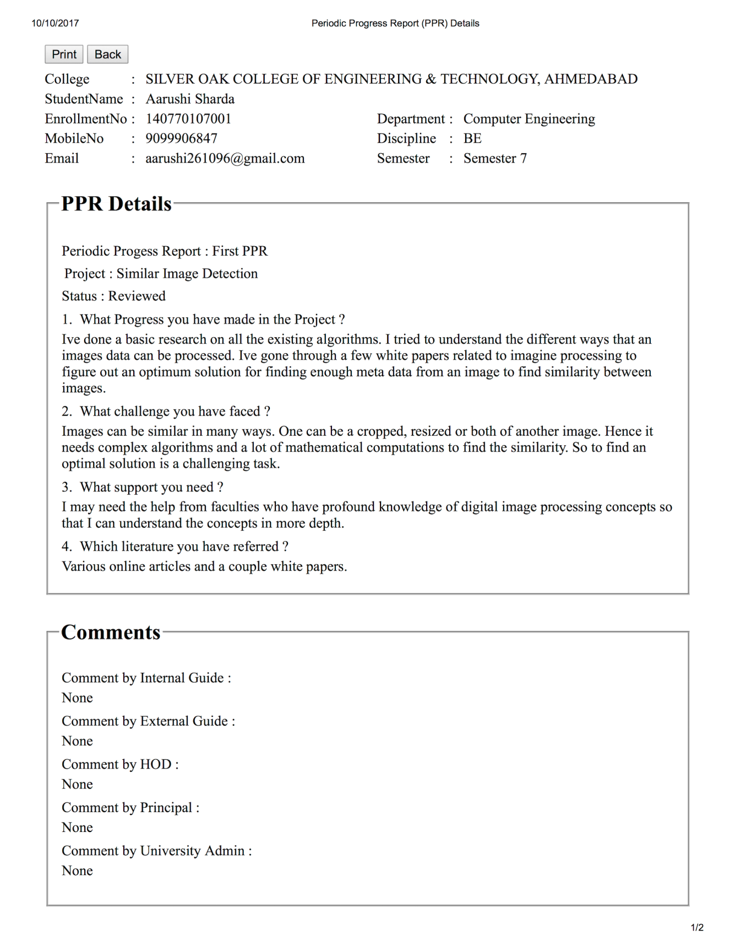



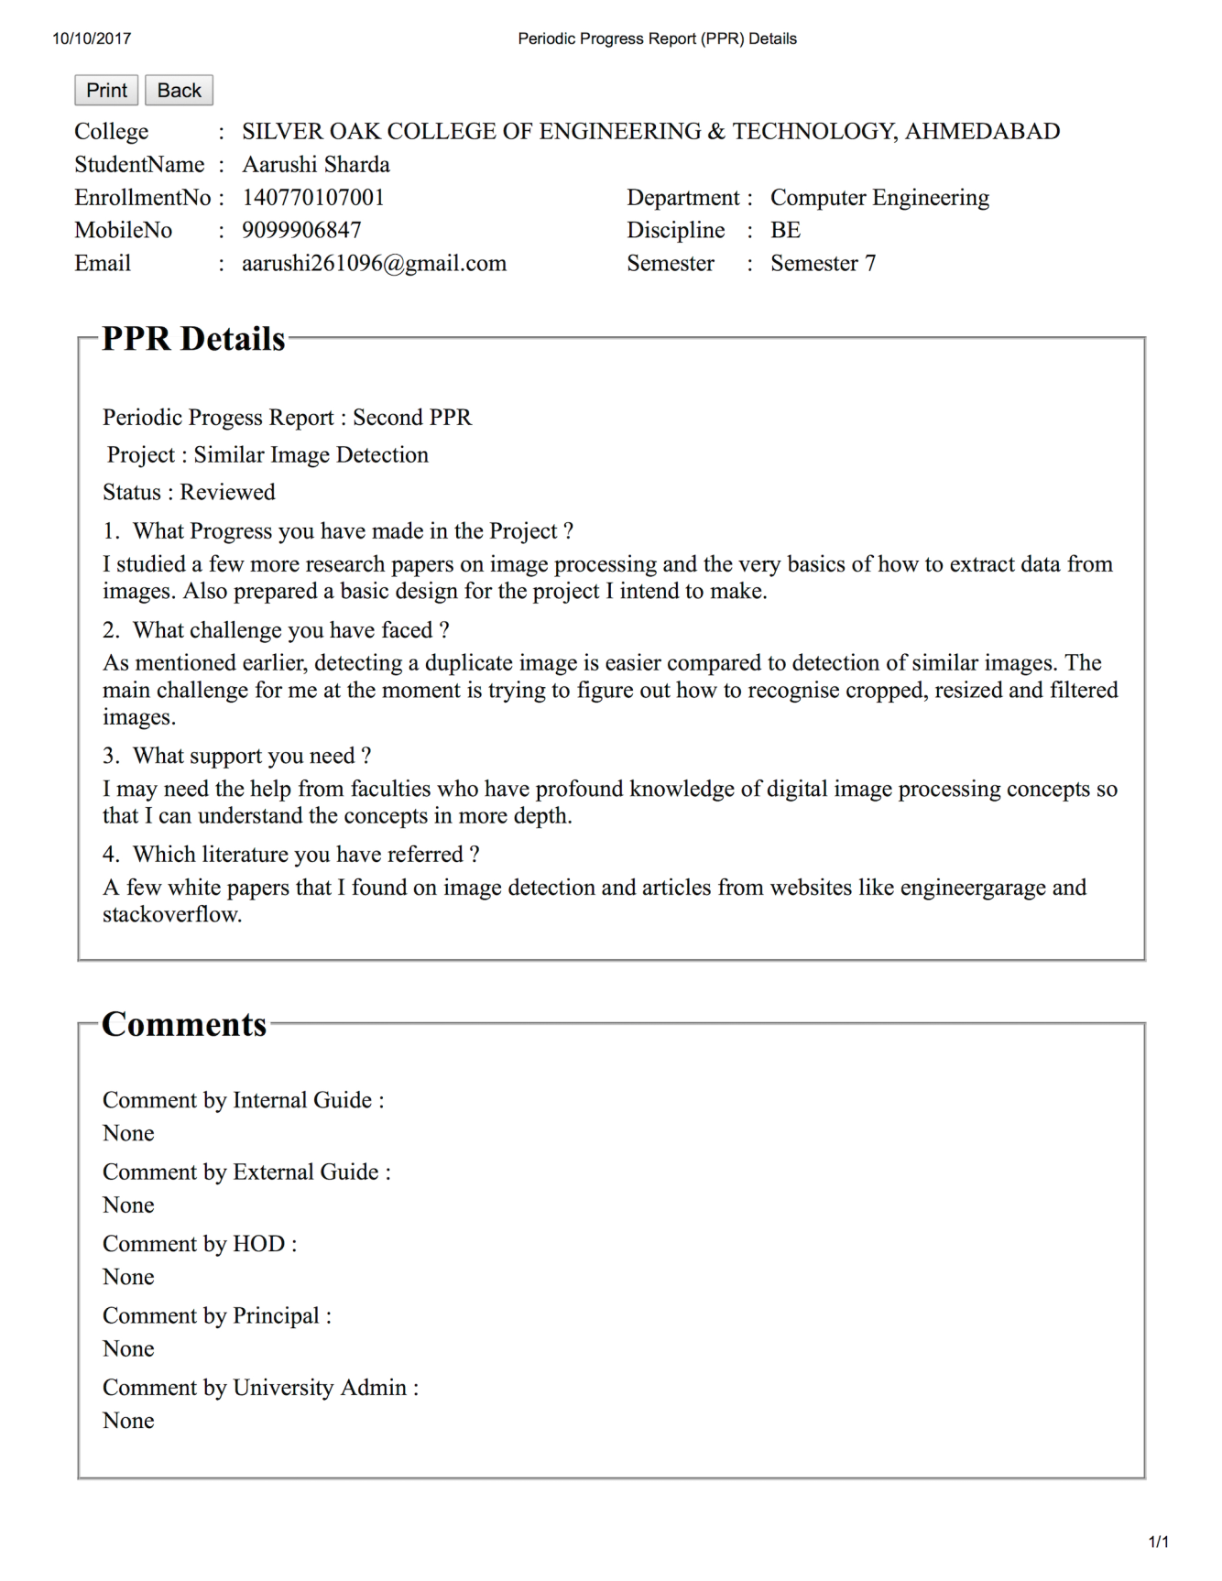**PPR-2**



**PPR-3**

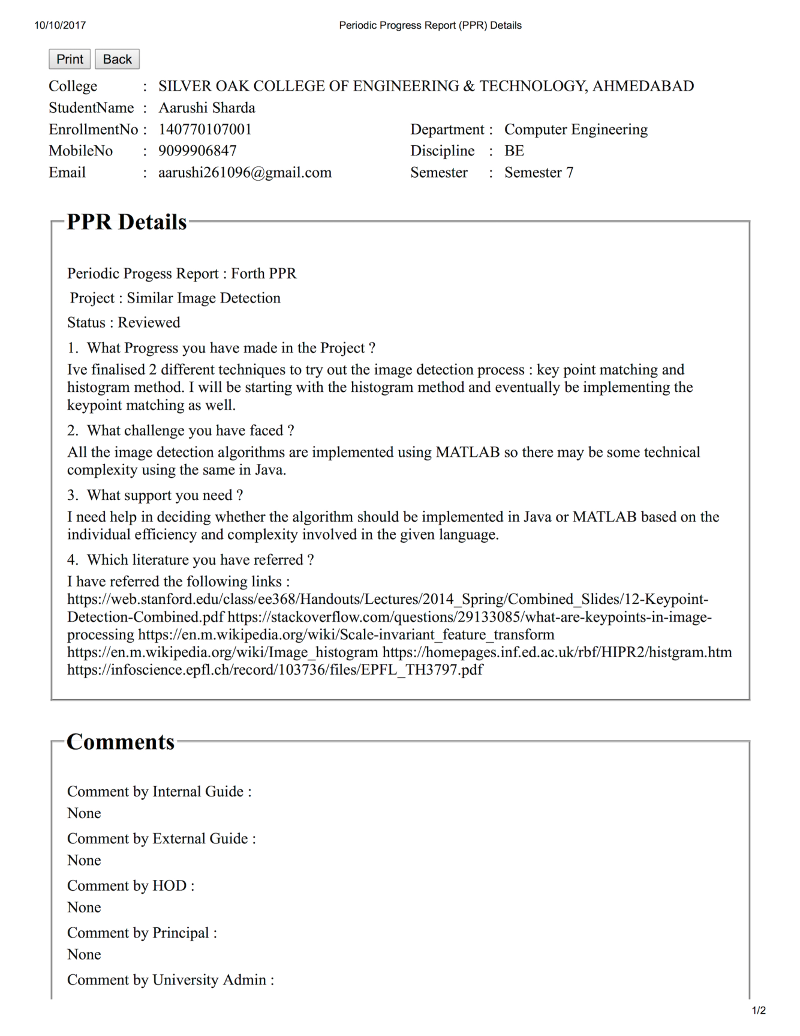

**PPR-4**

1. **PSAR (Patent Search and Analysis Report)**

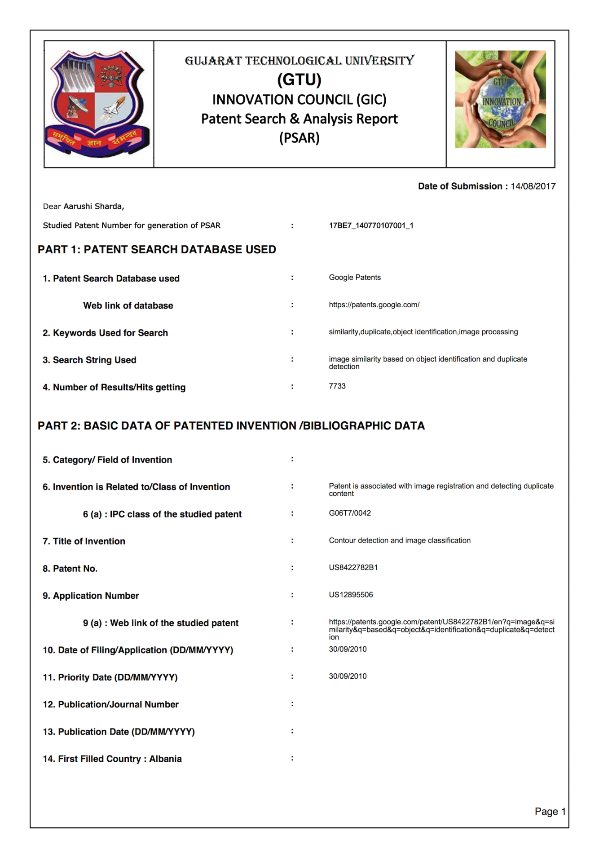



**PSAR-1**

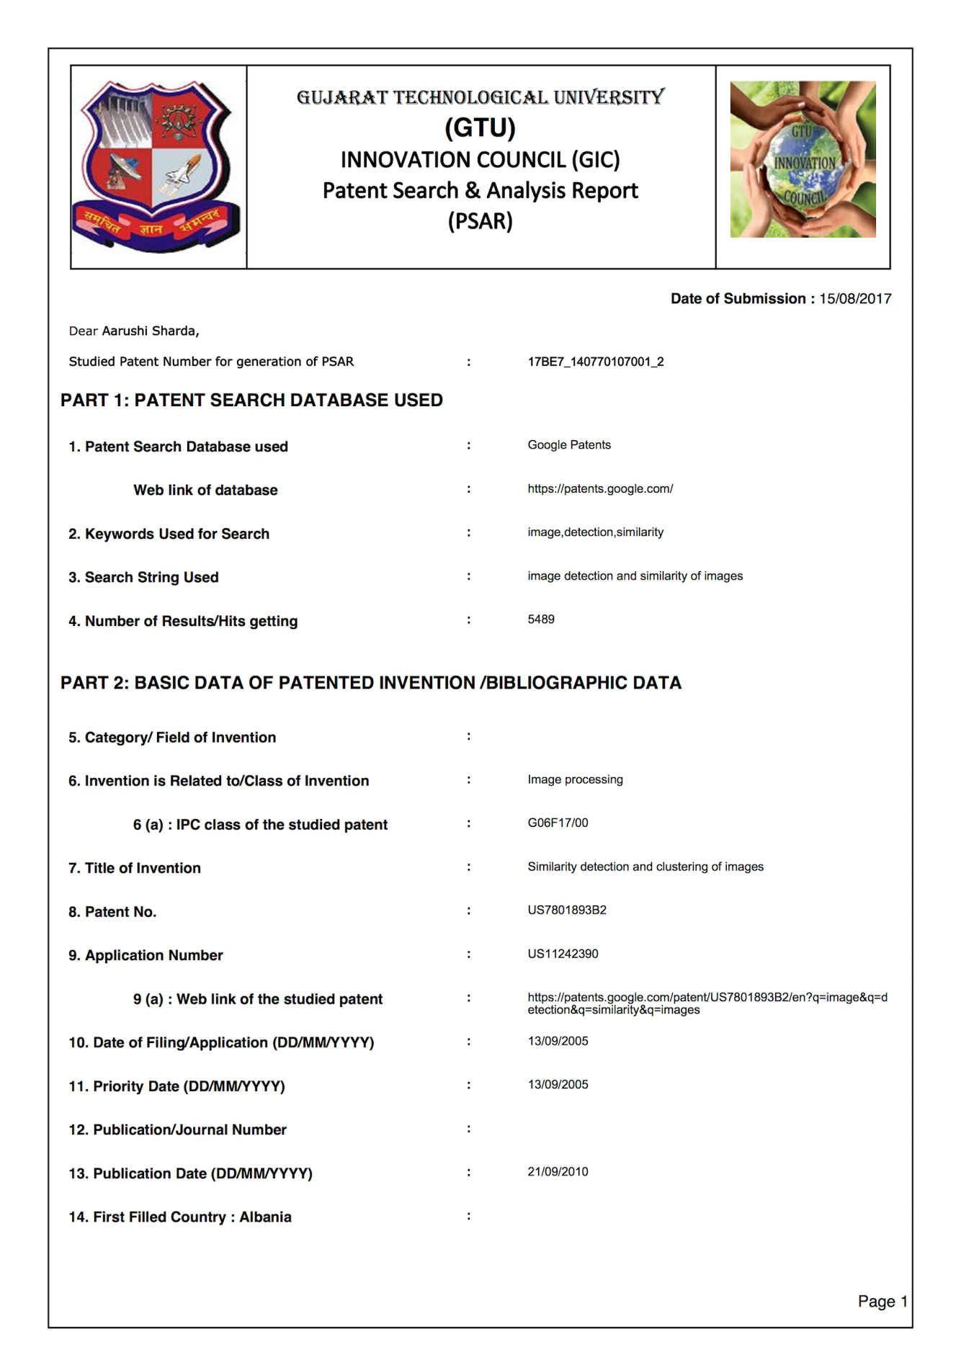

** PSAR-2**

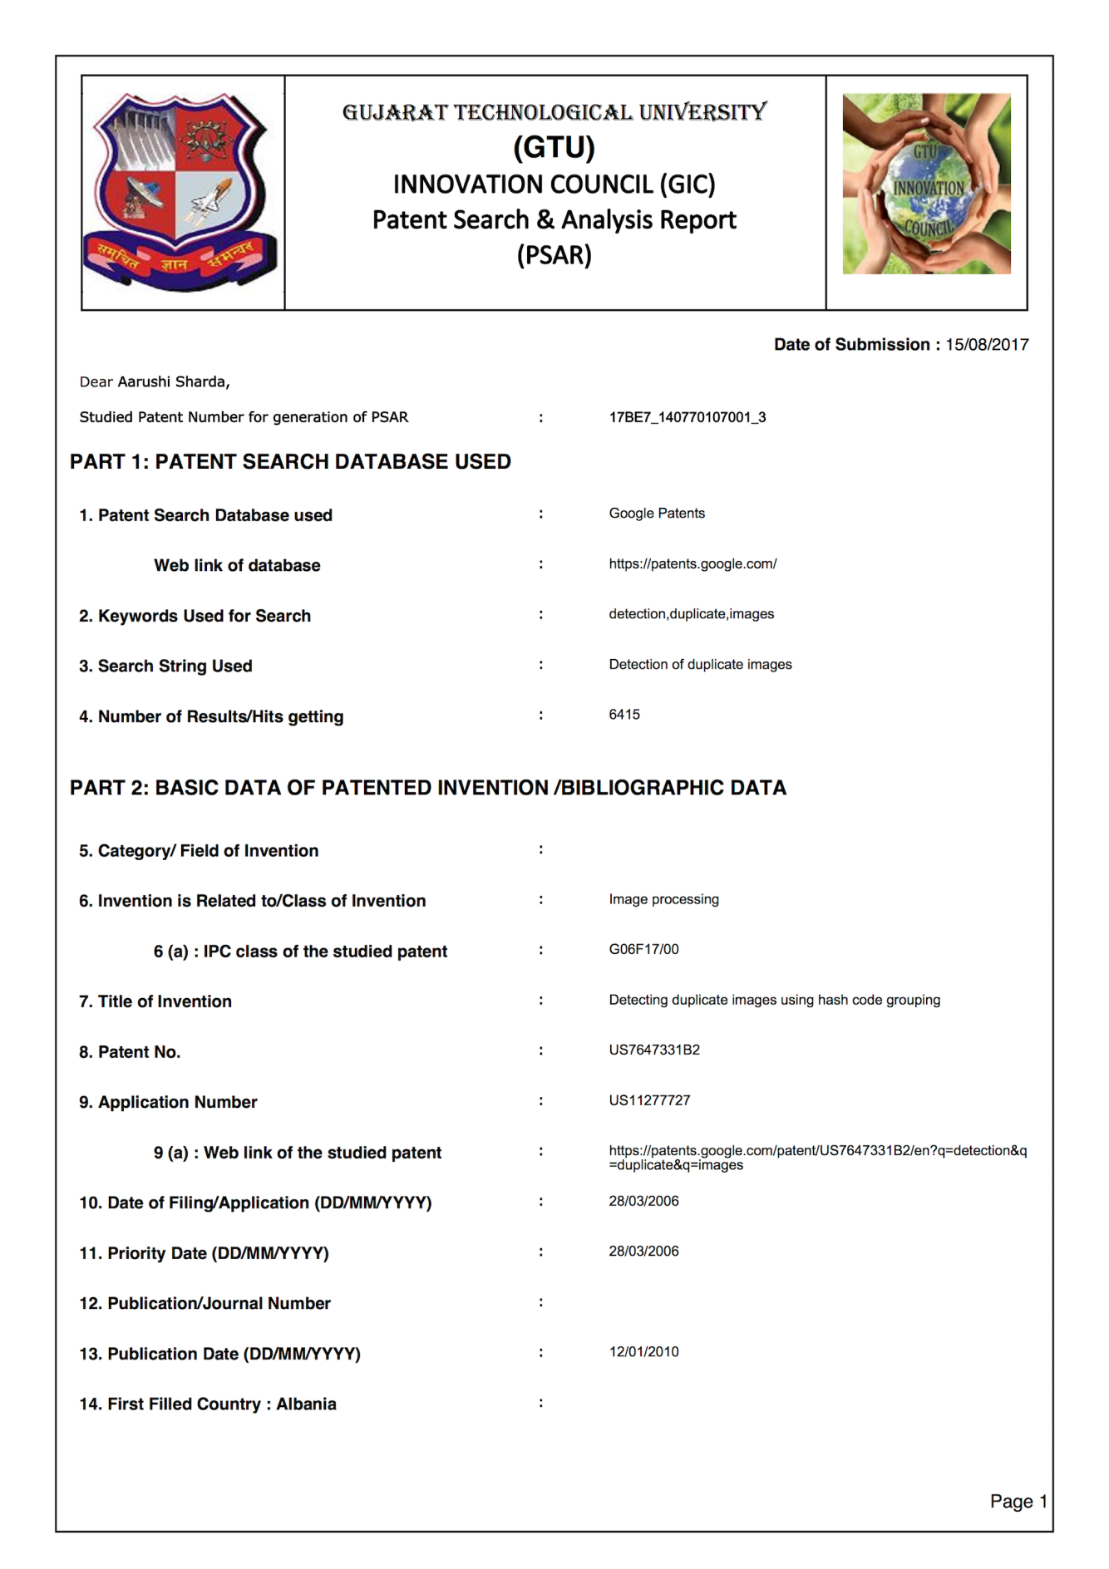



** PSAR-3**

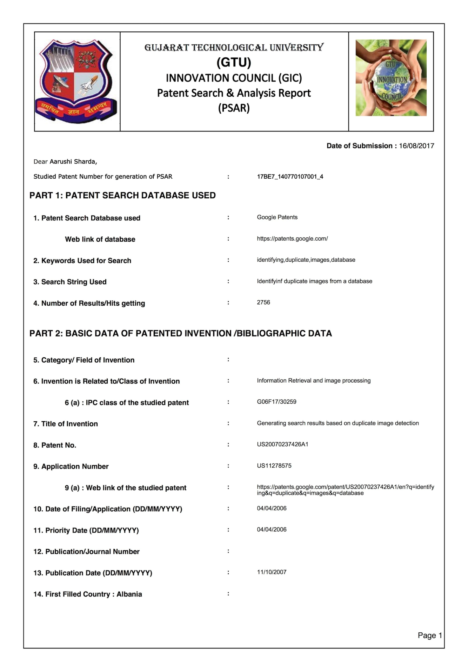



** PSAR-4**

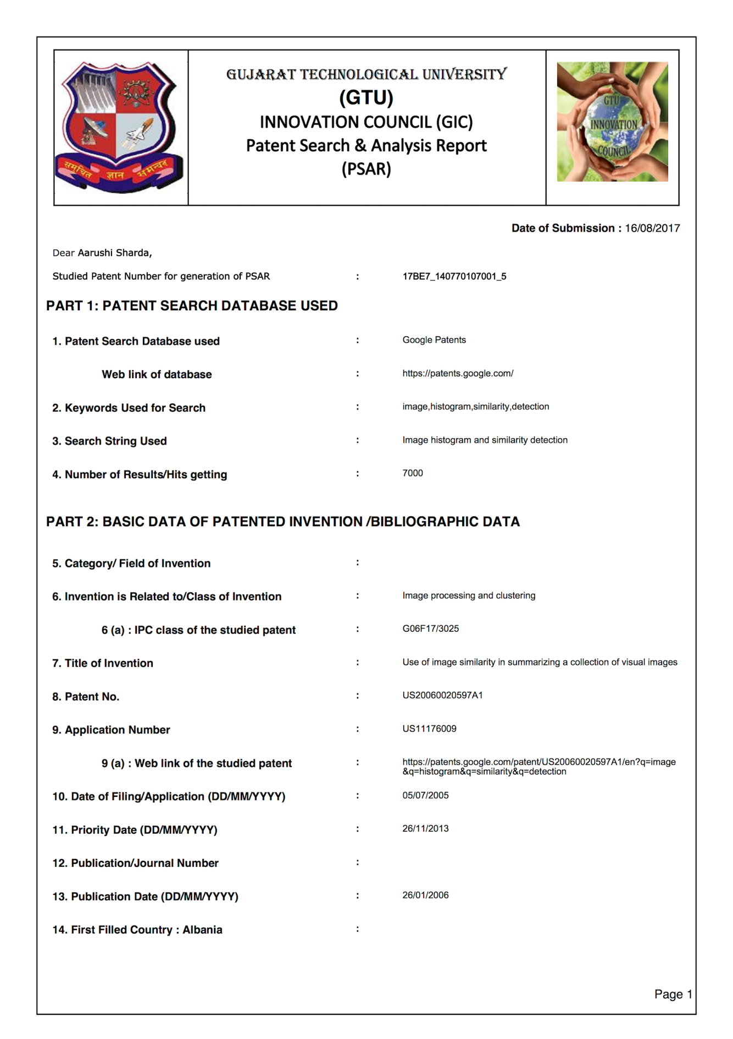



** PSAR-5**

1. **Design Engineering Canvases**

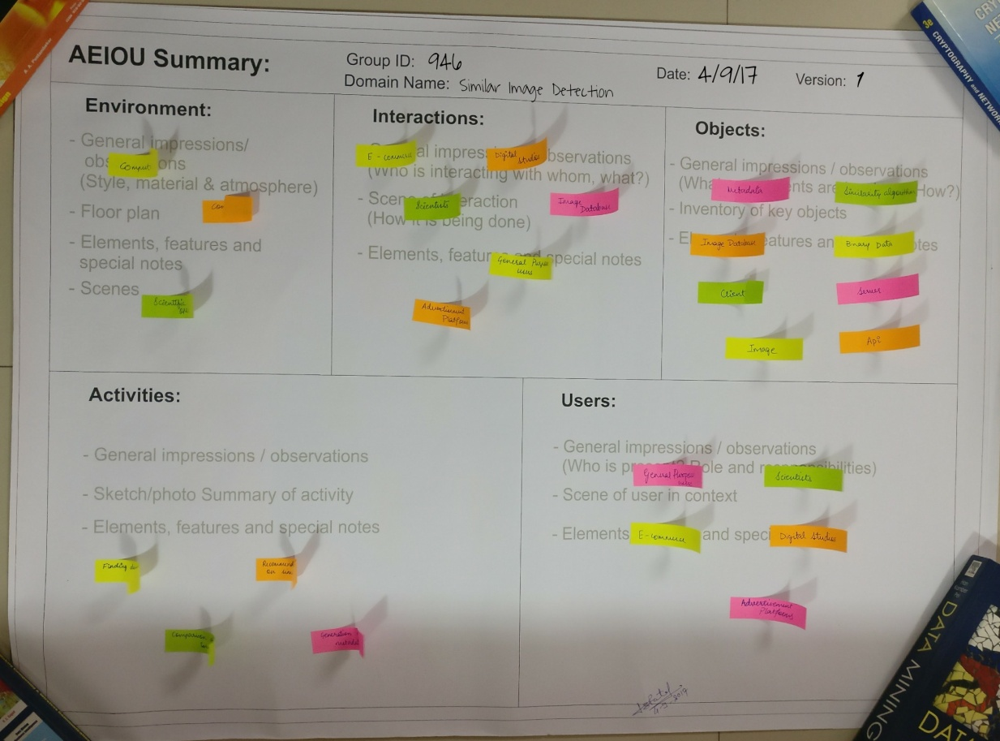

**AEIOU Canvas**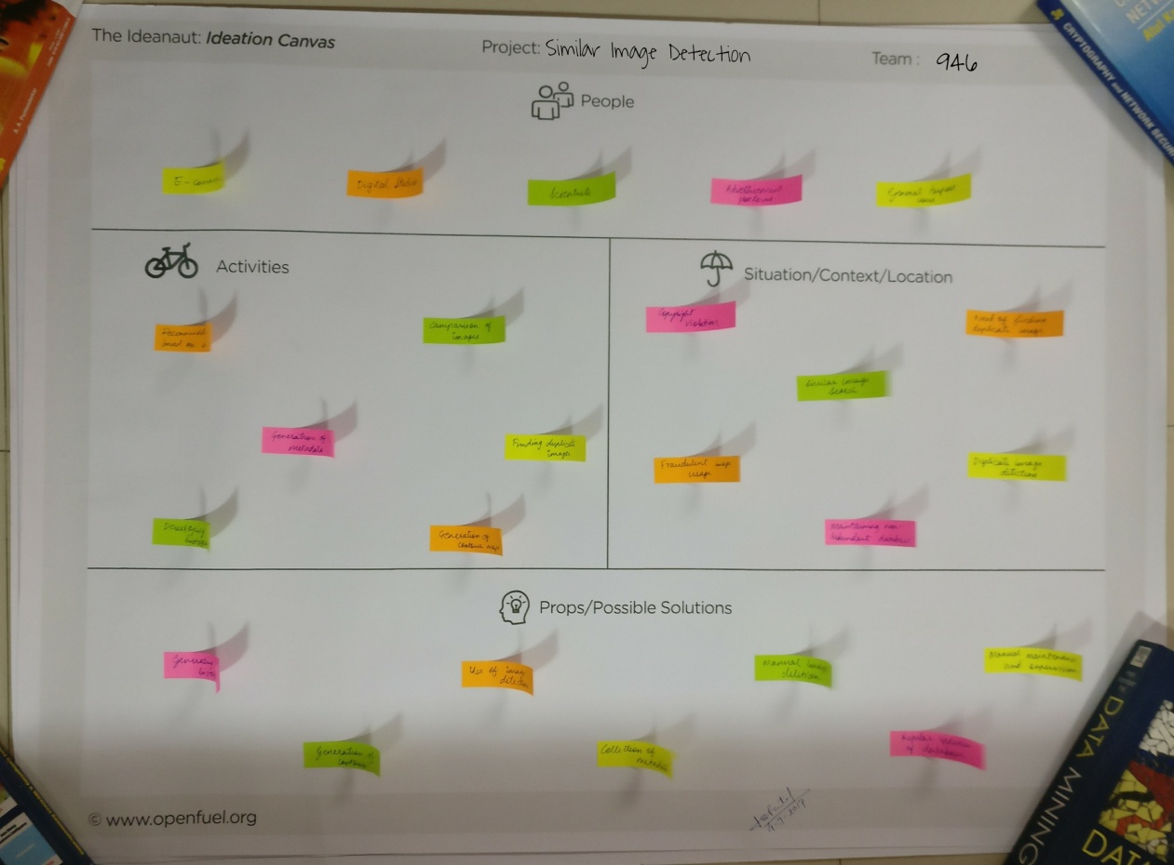

**Ideation Canvas**

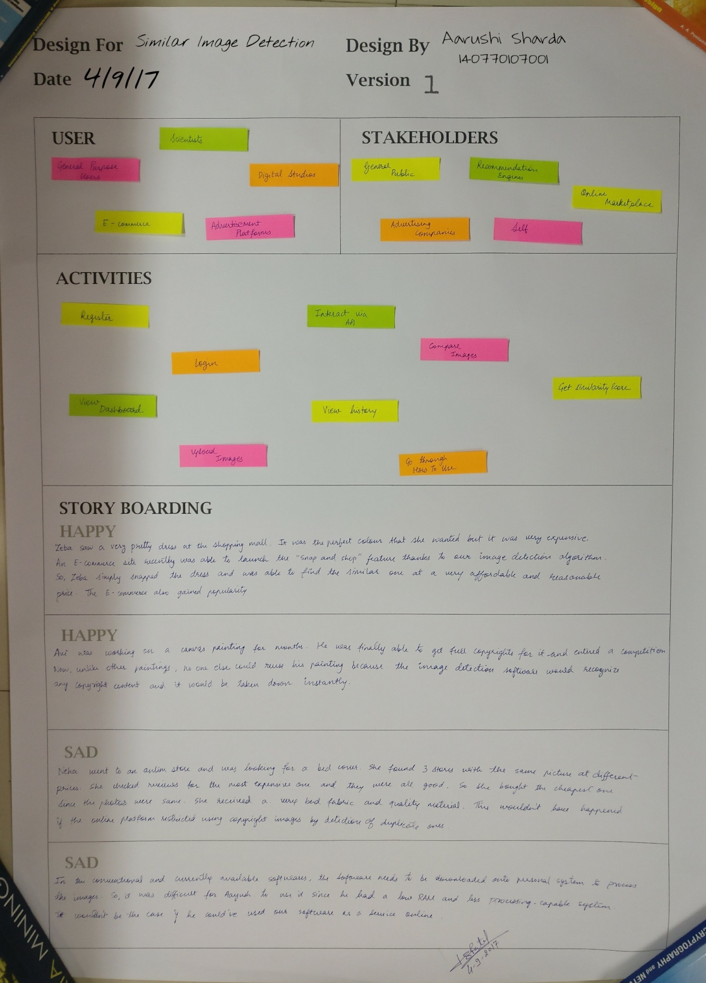

**Empathy Canvas**

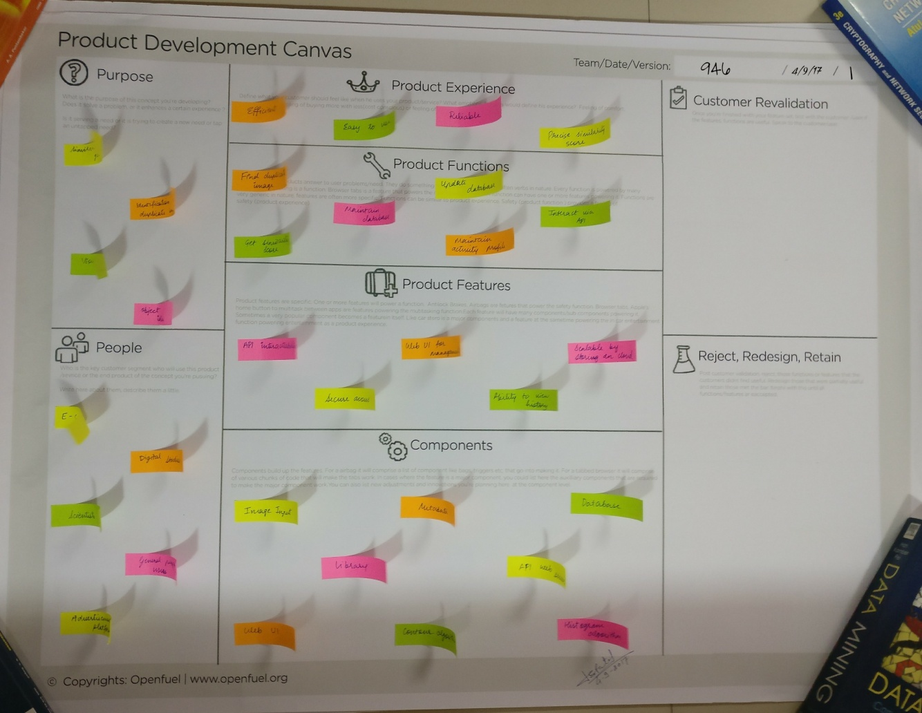

**Product Development Canvas**